February 18, 2022

*Via E-mail:* <<INSURED_EMAIL>>

<<INSURANCECOMPANY_SUITNAME>>

***RE:*** Notice to Insured

**Insured:** <<INJUREDPARTY_NAME>>

**Property Address:** <<INJUREDPARTY_FULL_ADDRESS>>

**Claim No.:** <<INS_CLAIM_NUMBER>>

**Date of Loss:** <<ACCIDENT_DATE>>

**Our File No:** <<CASE_ID>>

Dear <<INJUREDPARTY_NAME>>:

Your insurance company has refused to pay for the services performed by <<PROVIDER_SUITNAME>> on your property in connection with your claim. Attached herein please find a copy of the demand letter we sent to your insurance company in an effort to amicably collect the subject invoice from them.

We are sending you this demand because we are required to by law under F.S. 627.7152. For clarification, collection of this claim is not against you and does not make you responsible for any payment; this claim is entirely against your carrier, <<INSURANCECOMPANY_SUITNAME>>.

Should you have any questions please contact your service provider.

Sincerely,

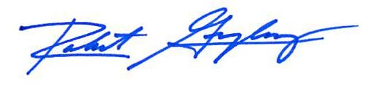

Robert F. Gonzalez, Esq.

Enclosures